Project 2020-1-DE03-KA229-077050_1

staff-training Hamburg, August 2022

Keen nich will dieken, de mutt wieken!

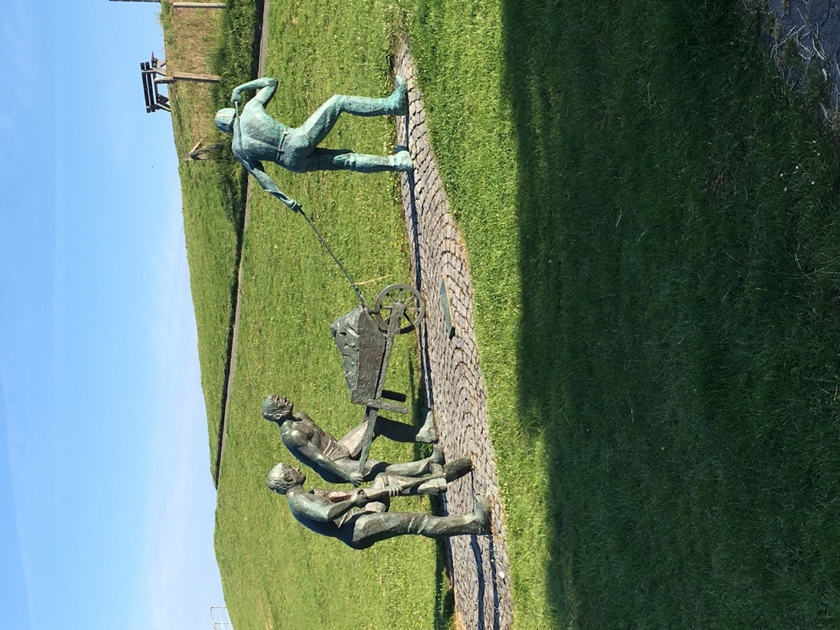
Photo: Peter Proeger

A monument honoring the people who constructed, built and maintained the dikes in Otterndorf at the bottom of the dike and close to the dewatering pump of the region

LENNART BENGTSSON

„Wissen ist das beste Medikament gegen Klimaangst“
Stand: 13:18 Uhr
15 June, 2022
“Knowledge is the best medicine against climate anxiety”

Von Axel Bojanowski
Chefreporter Wissenschaft

Excerpts of an interview.. (…)
“Bengtsson: I think the general public debate tends to see all climate change as something negative, without pointing out that some climate changes are positive or even natural processes that have always existed. The warmer climate in Europe today is more beneficial to society than the typical climate of the 19th century. In fact, the warming observed in the 1930s was viewed by virtually everyone as something generally positive. I fear that the strong politicization of the climate debate will have negative consequences for basic research, since some scientists are naturally skeptical and critical. As a result, some scientists are reluctant today to address issues that some universities and funders might view as critical to the IPCC.”
(…)
“I have strong faith in people's scientific and technical ingenuity and believe that it will thrive if we can maintain the current level of intense research and good international collaboration. The best countries can fund basic research to find new methods of generating energy with minimal negative impact on the environment. In 100 years, I believe that climate change due to greenhouse gases will no longer be an issue.”
(…)
Aus :
https://www.welt.de/wissenschaft/plus239362235/Lennart-Bengtsson-In-100-Jahren-wird-der-Klimawandel-kein-Thema-mehr-sein.html

Lennart Bengtsson, born in 1935, headed two of the most important climate institutes: from 1981 to 1990 he was director of the European Center for Medium-Range Weather Forecasts in England, then director of the Max Planck Institute for Meteorology in Hamburg. After his retirement in 2000 he worked as a professor at the University of Reading in England. The multiple award-winning scientist, including the German Environmental Prize from the Federal Foundation for the Environment, has primarily dealt with the modeling of climate and weather.

Staff training Hamburg

Von Pfeffersäcken bis zum Wattenmeer

Prosperous and poor (northern) Germany as a result of climate change and human activities over the last 10 000 years.
The landscape of northern Germany and especially, - since this is the region our project is dealing with - the region between Hamburg and the mouth of the river Elbe in Cuxhaven and her littoral -, have been shaped and still are by two major circumstances: The first and basic one is the still ongoing melting of the ice shield of the northern hemisphere, accelerated by human influence, and the second and resulting one is the active dealing with the changing environment by human settlers, shaping it to their advantage.

Ice Age and warm and cold periods
Approximately 10 000 years ago, northern Germany, as well as the major part of northern Europe, including what is now called Scandinavia as well as Schleswig-Holstein and Hamburg as part of Germany, mainly the region north of the river Elbe, was covered by an ice shield up to 3000 meters high. At the southern edge of this ice shield, which is scientifically the remaining part of the so far last cold period of the ice age, the river Elbe was the glacial river valley, continuously transporting the melting water of the ice shield to the North Atlantic Ocean for thousands of years.

Today’s course of the river still demonstrates this past situation even though the northern European ice shield has long withdrawn from this region and is not feeding this river anymore. Instead of melting snow and ice, rain, which is a basic element of the region all year long, is now the most vital factor feeding the river from its spring in central Europe to the mouth of the river. Only during snowy and icy winters, which do not happen very often anymore, springtime´s melting periods sufficiently add to the water of the river.
Therefore, on the last 100 km of the river a sufficient water level is all year long provided to guarantee shipping to the harbor of Hamburg, the most important one in Germany, allowing to generate its wealth based on the worldwide ties to harbors all over the planet.

North of the river we can find a landscape directly shaped by the ice shield, as, in a natural process, it transported rocks and sand from Scandinavia to the more southern parts of the shield. Remainders of that, the moraines, can be found in the parts of Hamburg north of the river and in Schleswig – Holstein, north of Hamburg.

Loss of land and human lives and gaining fertile grounds
South of the river and in parts also north of it, west of the city of Wedel, which was then south of the ice shield, an almost completely different landscape has come into existence.
10 000 years ago, when the ice shield still covered the region north of the river, the southern part was, what is now called a tundra, a landscape similar or equal to what we still find in northern Siberia, eventually disappearing over there, too, as recent observations prove. Permafrost was the prevalent condition, leaving only low plants adapted to these, for humans unhospitable, conditions of nature. Agriculture and resulting permanent settlements had not been possible. Hunting wild animals, including fishing, and collecting fruits and roots from small plants had been the only basis for the survival of human life.
But then climate started to change the situation again for the fourth time during the ice age in the northern hemisphere. Temperatures started to rise causing the ice shields to start melting, a process that is still going on.

- In addition to that, the glaciers of the central and southern European mountains as well as the ice shield in the southern hemisphere and of course in North America had started to melt. But since we are dealing with the region of northern Germany presently, the melting of the ice shield, which has still not come to an end, and its results, are in the focus. –

From now on two major circumstances started to shape the region south of the river and in what is called the North Sea now.

Doggerland, now Doggerbank, and more
First of all, it was the rise of the sea level, amounting over the last 10 000 years to approximately 200 meters in northern Europe. What is now the North Sea, a shelf sea, had been dry and fertile land temporarily even with settlements of humans over a certain period. The mouth of the river Elbe was situated as far north as what is now called Scotland, pouring her water into the North Atlantic Ocean. Time after time the rising of the sea level caused loss of land in this area. The land bridge to Great Britain was lost and the North Sea became a rich fishing ground to the neighboring settlements to the sea. Until today this process of a rising sea-level has not come to an end and will, provided the natural process will continue as it did in the cold periods before, cause an even higher sea level.
The island of Helgoland, situated in the North Sea, which we will visit during our staff training, was then a constituent part of the land. Whereas we will have to board a ship – a two-hour trip - to go there, our ancestors could walk over to the place and did. Similar to that, we can still walk to a different island, called Neuwerk, only 10 km off the coast of Cuxhaven, not quite as far as Helgoland, and only during low tide (Ebbe).
https://www.youtube.com/watch?v=BV7_XxGh2pA
Helgoland used to be a burial ground for the chiefs of Germanic people. (Helgoland – Heligo Land means holy land or holy (burial) grounds.)
Again, time after time the rising of the sea level, erosion and in addition heavy storms took away more and more from that land. This natural process is still going on and will be going on unless the coastal regions are not artificially protected by human activities.
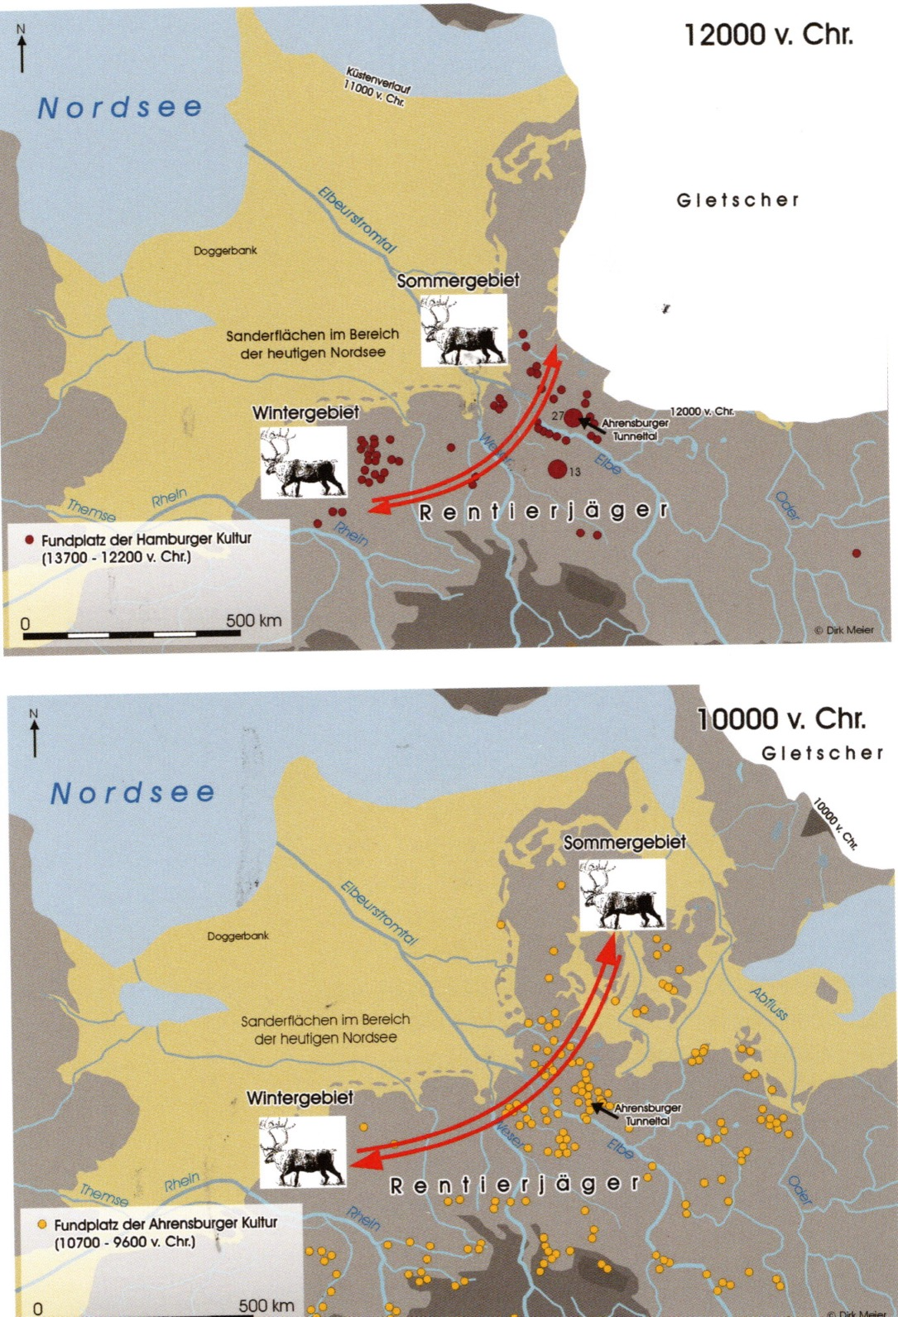

The meandering river and wetlands
As all rivers worldwide, if not forced into a more or less permanent bed, the river Elbe had the opportunity to meander on a wide scale. South of the river, mountains, except for moraines from previous cold periods, were and still are of course, far away and so the river used to meander, relocated its course continuously. Therefore, the present main current had never been a permanent one. In addition, caused by alternating high and low water levels, caused by the tides and continuously heavy rainfalls it produced a vast wet land area stretching over hundreds and thousands of square kilometers before humans started to prevent that from happening. But it was not until the medieval times that first attempts were made to prevent the river from following the natural meandering path.

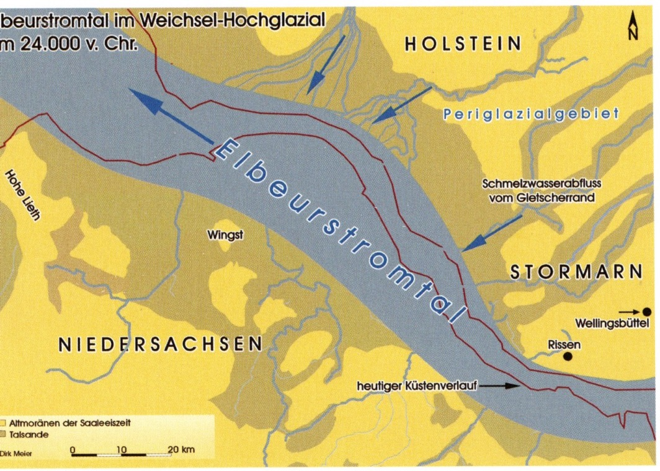
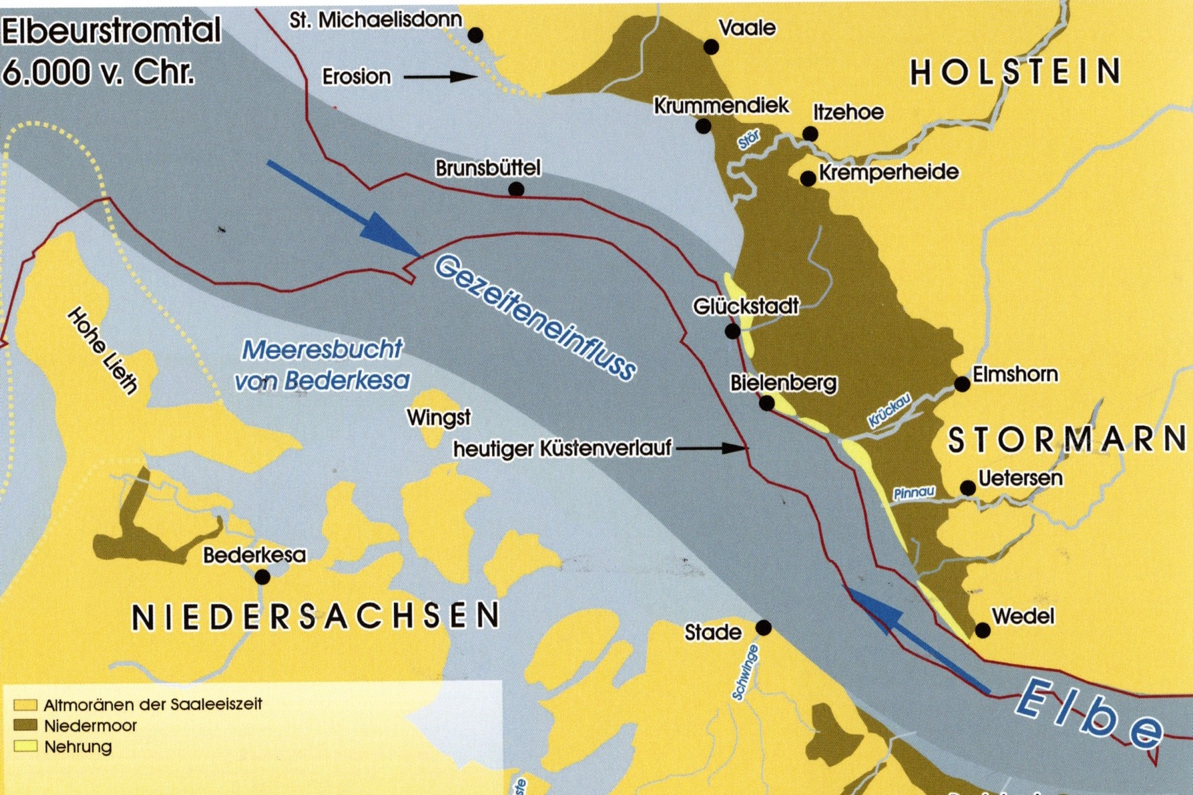

Fertile grounds/marsh land (Marsch) and poor grounds/moors (Moor)
These wetlands alongside and closer to the river proved to be a very fertile ground for plants and a rich fishing area as well, as it provided nourishment for fauna and flora as well. Therefore, it was not surprising, that human settlements followed these conditions even though surviving under these circumstances proved to be more than a hardship, often deadly, to men, women and children.
But here still is a saying: “Dry years are golden years in the marsh”. Which means: It is quite normal to have rain more or less all year long and sometimes during summer, if there is too much rain, it even causes crop failure.

If successful and having survived, the settlers of this area most of the times since early settlements about 2000 years ago managed to be among the wealthiest farmers in Germany especially in the latter years of the medial times and in modern time. Huge farmhouses are still witnessing this along the wider banks of the river.
Contrary to that, the settlements of the moors belonged to the poorest in the region.
They were further inland, where moors are prevalent, the situation was completely different. Small huts or farmhouses on the agriculturally poor soil still witness the bad living conditions of the people on that part of the wetlands. Until the 1930s boats were the usual means of transportation in this area. Only since a huge dewatering system, including large pumps running all year long, had been installed it was possible to construct roads and get cars and trucks into that area and also intensify agriculture. Before that it was mainly possible to raise cattle and pigs instead of growing plants.
But, as we will see during our train ride from Hamburg to Cuxhaven, dewatering plays an important role in the survival of the people and the success of agriculture.
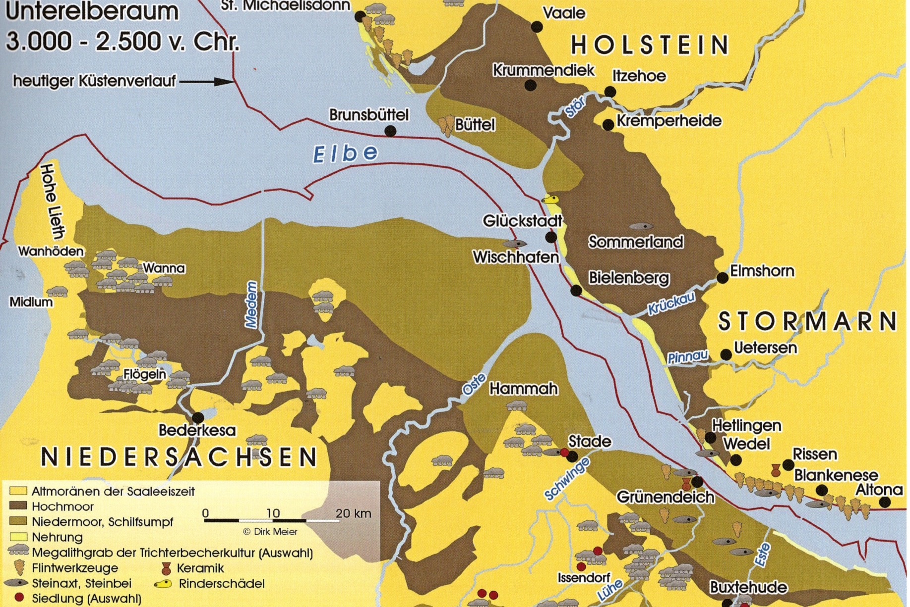

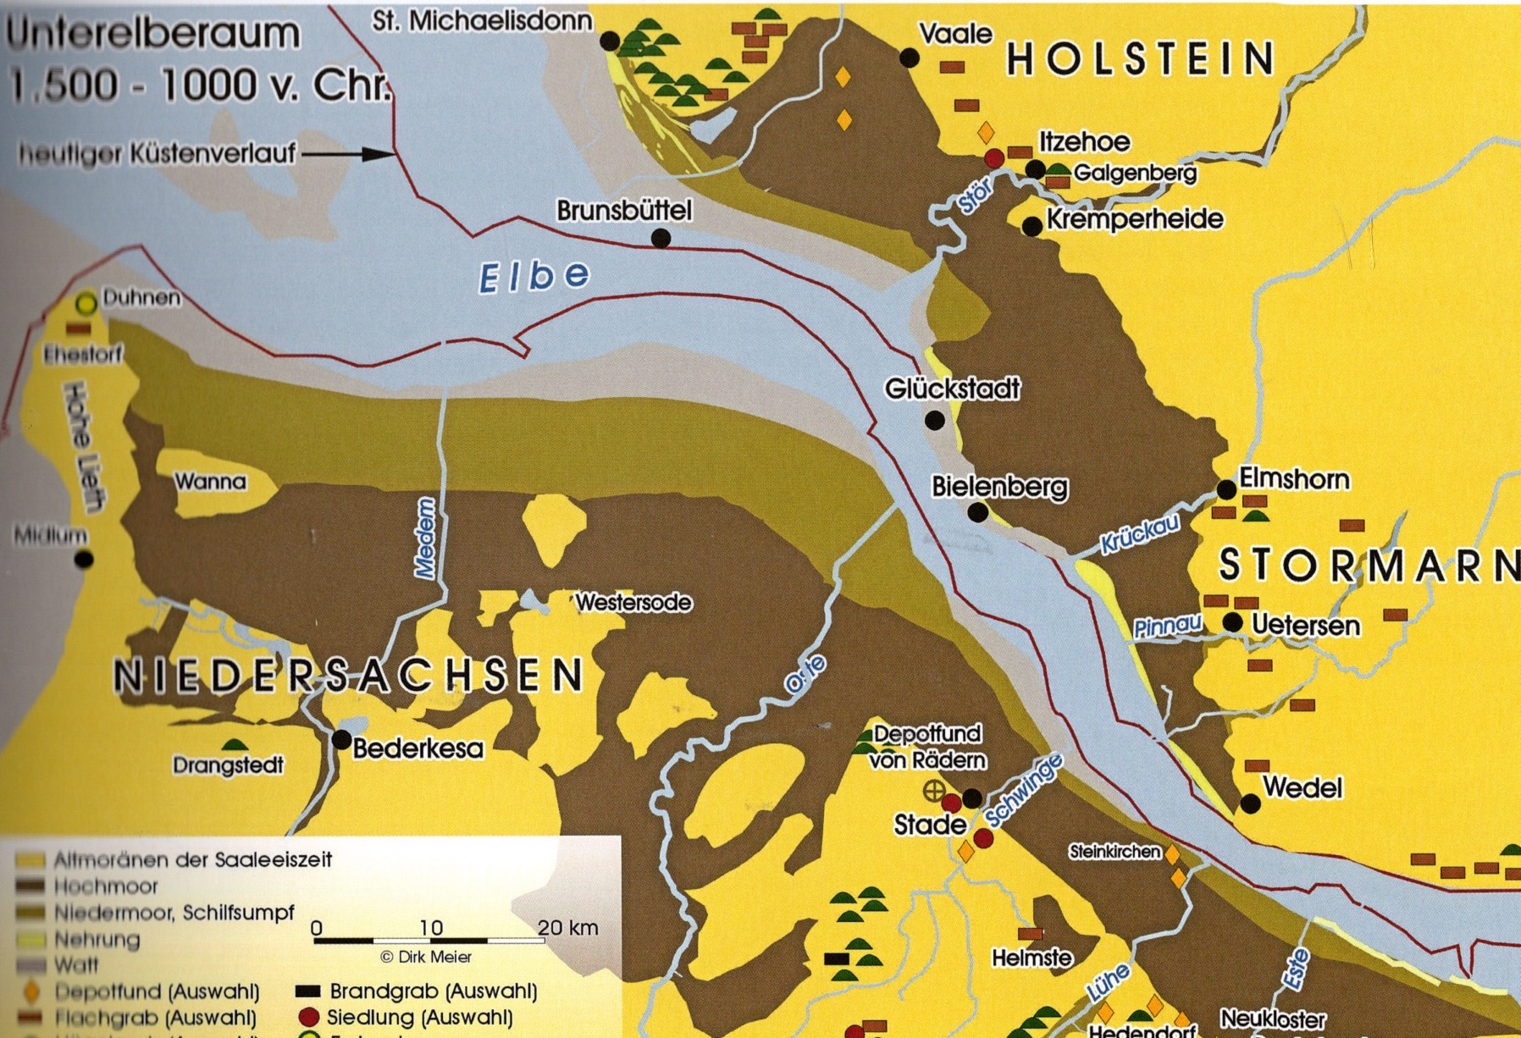

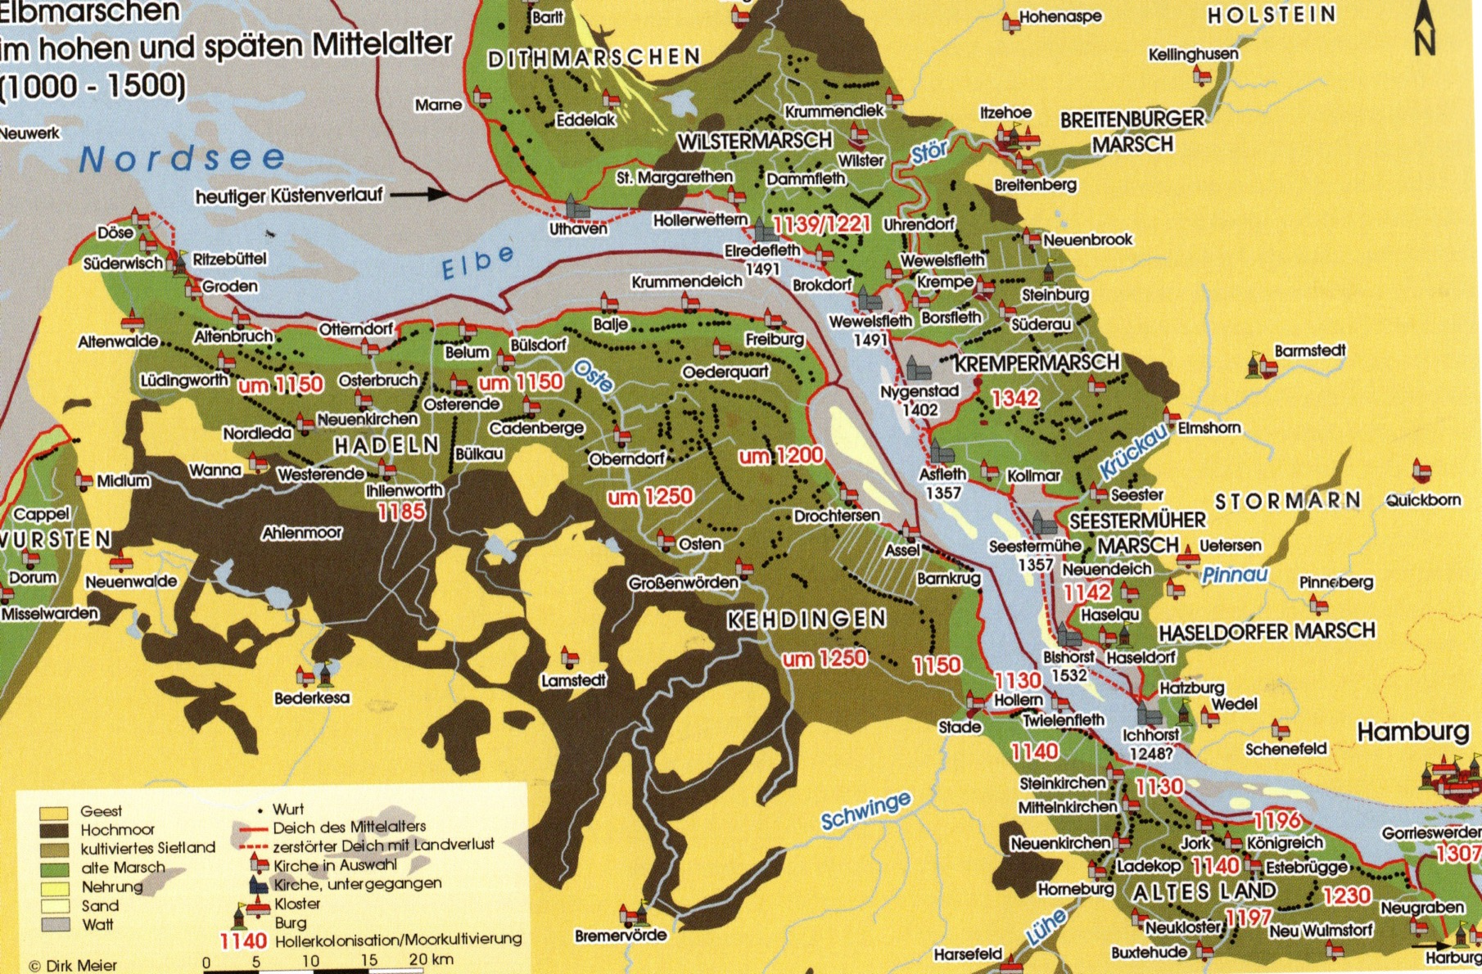

Emigration
Despite the fact, that part of this region belonged to the most fertile grounds and contributed to the nourishment of many people, it still was a most difficult and an often deadly task to make a living.
Especially in the moors in the western part of northern Germany, close to what is now the Netherlands, then part of the “Holy Roman Empire” a saying was invented: “Dem Ersten der Tod, dem Zweiten die Not, dem Dritten das Brot”, (which translates: The first one will die, the second will suffer from poverty and only the third one will have sufficient bread to survive.) Despite the fact that this is probably true in many regions, it is nevertheless true, that to make a living there was extremely difficult.
Therefore, it was not really surprising, that some day people decided to leave this part of the country and settle elsewhere. Between 200 and 600 after Christ mainly the moor area was almost completely uninhabited. People left, together with thousands of people of northern Europe, their homes and found new places to stay. The Angles and Saxons from northern Germany and Denmark crossed the North Sea and settled in Great Britain. Like many other settlers throughout history, they took everything and moved it to another place to have a better life. Most generally only few people were left behind.
(Not too far away from Cuxhaven there is a small village, named “Odi(n)sheim” which bears a second name: “Godshem”, both have the same meaning: “God´s home”, because Odin was a Germanic god. People of this village took this name and founded a new village in the southern part of England (the “Angles´ land”), where it still exists. Bill Clinton´s ancestors supposedly came from this village)
Other people, mainly from northern and eastern Europe, at that time of the so called “barbarian migration” decided to invade and/or simply settle in southern Europe in what is now called Italy, Spain, Portugal and France and even in the northern parts of Africa for similar reasons.
A colder climate alongside with other reasons was supposed to have triggered this migration.

Wurten and dikes (De nich will dieken, mutt wieken.)
But after a while, when the number of people living in Europe slowly increased, new settlers came and started to establish new settlements in the area again. This time they stayed and started to actively shape the environment in order to survive permanently.
Still the river and its wider littoral were more or less a huge wetland, where people could only live and survive during the summer in the lower parts of the country, even though a rather wet one. During the winter they had to stay on higher grounds, the moraines, because storms, rain and flooding were and still are the normal kind of weather conditions we have here.
Since there were some remaining moraines from earlier cold periods of the ice age, people stayed up on these “hills” during the winter. Later on, they started to form artificial hills, “Wurten or Warften”, usually consisting of clay piled up two, three or more meters high. They build houses and stables on these “hills” in order to stay on their ground during the winter season. When more people were there, they started to build dikes, first only around small settlements, again only a few meters high, later on along the river in order to keep more and more land dry for a longer period than only for two or three months during the summer.
Up until today these dikes have been replaced by bigger ones every time it seemed necessary. In Cuxhaven, they are now, as a result of the last improvement after the great flood in 1962, about 11 meters high. Also, we meanwhile have an uninterrupted line of dikes from the mouth of the river Elbe to the upper part of the river, for hundreds of kilometers.
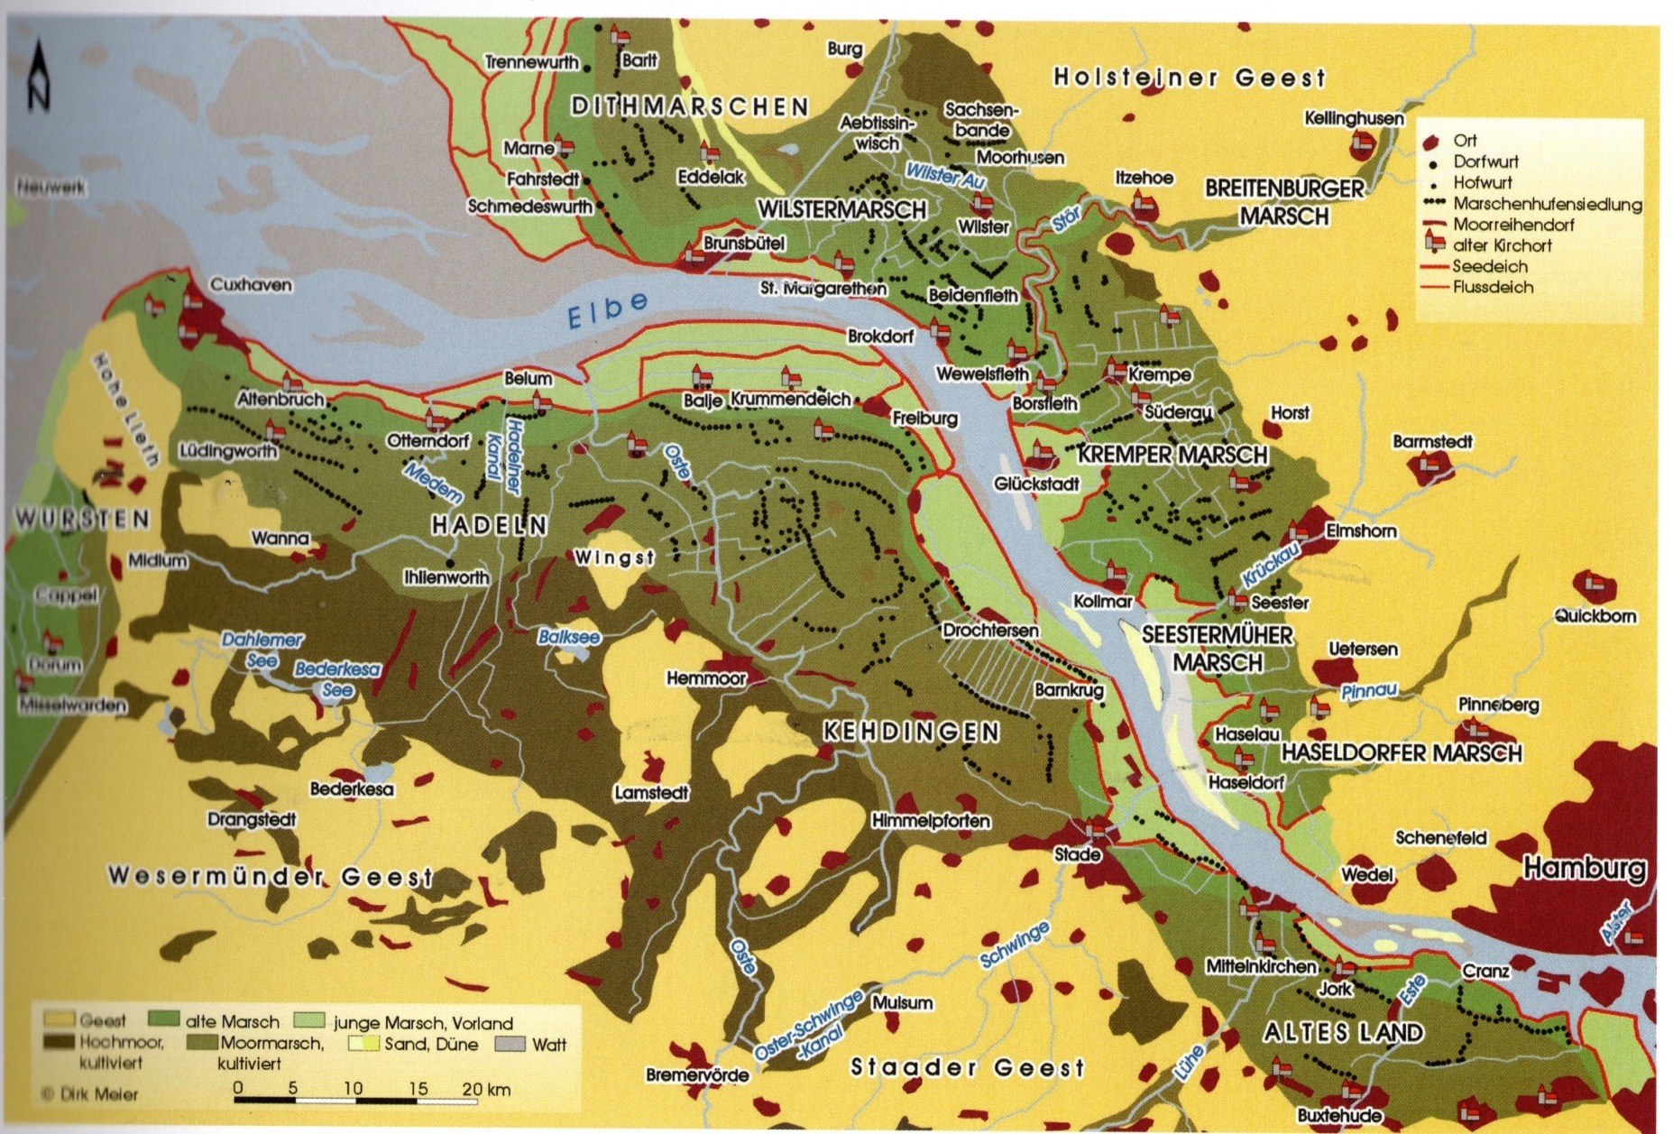

Spatenrecht (law of spade)
During the medieval times people from the Netherlands came over to teach the people how to build dikes, because they were and still are in an even more pressured and endangered situation, always threatened by the sea. They “invented” the dikes along the coastline of the North Sea. Amsterdam today for instance lies 6 meters below sea level.
As the only way to make a living during early medieval time was agriculture, it was the farmers who were held responsible for the building and maintenance of the dikes. Every farmer who owned land was compelled to actively participate in this activity. It usually meant coming out for building and repairing the dikes during the wintertime, when there was no work to do in the fields. Also, after heavy storms all male farmers and their male farmhands had to come and help. They had to bring horses, oxen, carts and shovels, handbarrows and of course spades, to dig clay and transport it to wherever it was needed. And since every year heavy storms usually occur and often damage the dikes, it was (and still is) an annual most difficult and also expensive and exhausting obligation for all residents. Therefore, ownership of farmland was connected with the ability and potential and the willingness to deal with this vital task.
If a farmer felt he could not take part in this anymore for whatever reason, he would take his spade, simply stick it into the dike and from now on he would not have this obligation anymore. But the moment he did, he would lose his farm and it would be given to someone else who could cope with this challenge.
Up until today, there is an ancient law which has never been abolished, that requires all male residents of this area from the age of 18 until the age of 60 to be ready at all time to help repair the dikes in case of emergency, which usually means before, during and after a heavy storm.
The moment I came back from university and settled here in my hometown, I received a letter calling me to duty for this purpose, and even though it had never been necessary for me to come into action, since the last dangerous flood took place in 1962 with broken dikes and hundreds of people and thousands of animal dying, I still received the annual order to be ready until I turned 60.

Heavy storms with loss of land and lives throughout the centuries

A short (and incomplete) list of severe floods is attached in addition to the Wikipedia link of complete list of floods throughout the centuries.
Only known floods are in that list, but certainly before humans documented those floods one way or another, there had been floods that took land and lives over thousands of years. Heavy storms with strong winds from the northwest at the coastline of western Europe are well known and will continue to happen each year. Other, but seldom, events like tsunamis can also cause similar damages and destruction.
These storms have always accompanied the rise of the sea level in this area.

It is also known, that damage or loss of lives throughout the centuries diminished. Had there been 10 000 or more victims of a single flood in ancient times, still even in the medieval times, the number of victims were reduced, not because storms were not as heavy any more, but instead because humans managed to protect themselves and their belongings starting a couple of hundred years ago.
Dikes, which are now present along the coastline of all adjacent countries play a vital role in this protection. But other measures as dewatering systems and water gates and other facilities add to this.

It was and still is a constant fight against the overwhelming power of the sea and the weather conditions and of course the natural climate change, now accelerated by human activities. Only through these measures provided by many generations we are in the comparatively comfortable position of living in a safe region at least for a while.
One big storm surge can take away all this comfortable life within 48 hours.
The last big flood we had was in 1976. If our dikes had not been improved and raised to new heights after the 1962 flood the Unterelbe region would have been devastated again in 1976, then. In 1717 a storm surge supposedly heavier than every storm since devastated the area before.

https://de.wikipedia.org/wiki/Weihnachtsflut_1717

Most facts stated as well as all maps included are taken from the book :

Dirk Meyer, Die Unterelbe, Vom Urstromtal bis zur Elbvertiefung; Boyens Buchverlag, Heide 2014

